Disability Law 2028
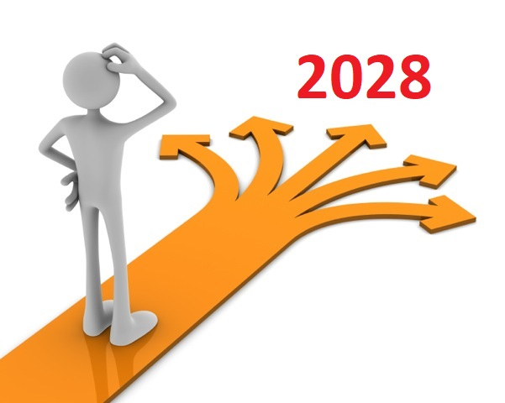Introduction

Where Disability Law want to be in 5-years’ time.


Disability Law 2028 was created in 2022 and 2023.

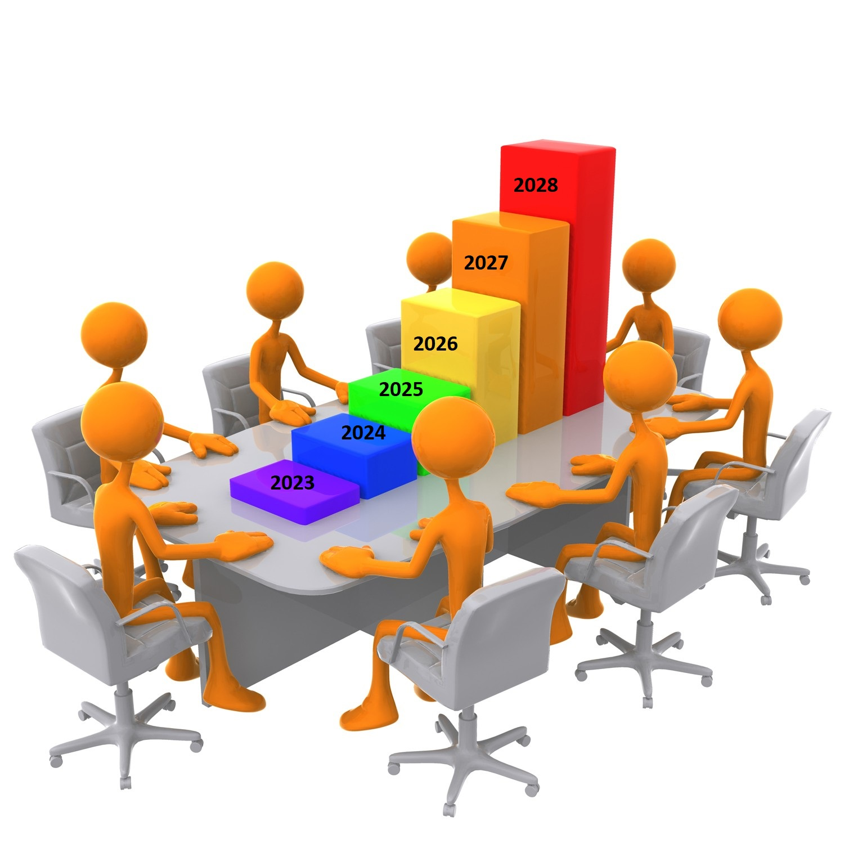

With the help of ADL Steering Group, management, staff, and stakeholders from the Deaf, disability and justice communities.



It tells the direction that ADL wants to go in and what ADL thinks is most important to do.

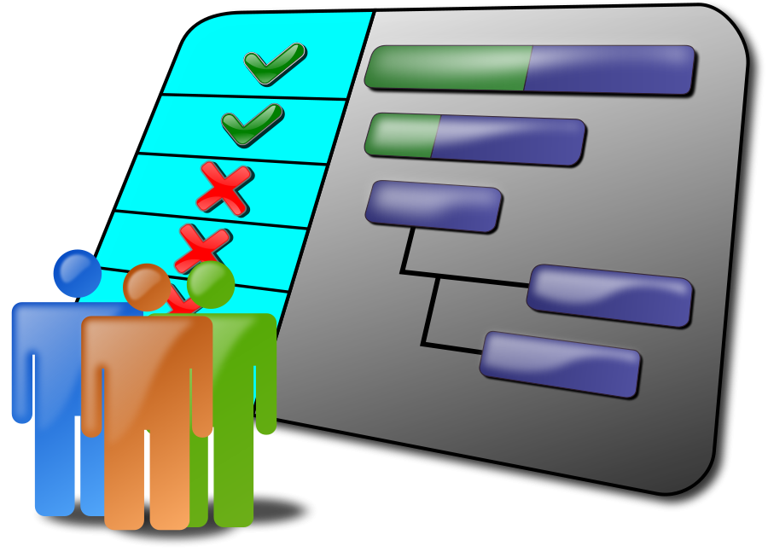
ADL Management will put together a yearly work plan report, and
Talk about the work plan report at each Steering Group meeting.


WHY WE ARE HERE AND OUR MISSION

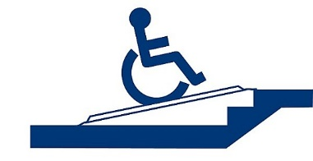

Our Purpose is to change lives - Make the law accessible

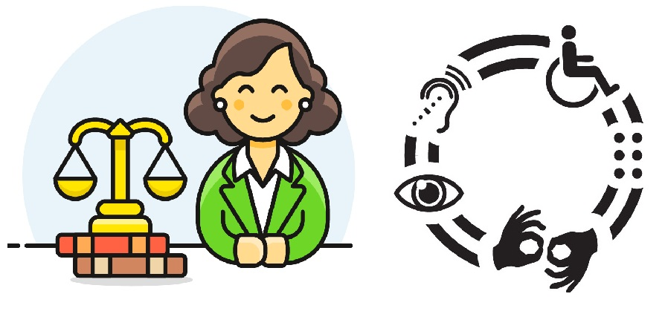
Provide accessible legal services to the Deaf and disability communities



Work closely with our partners

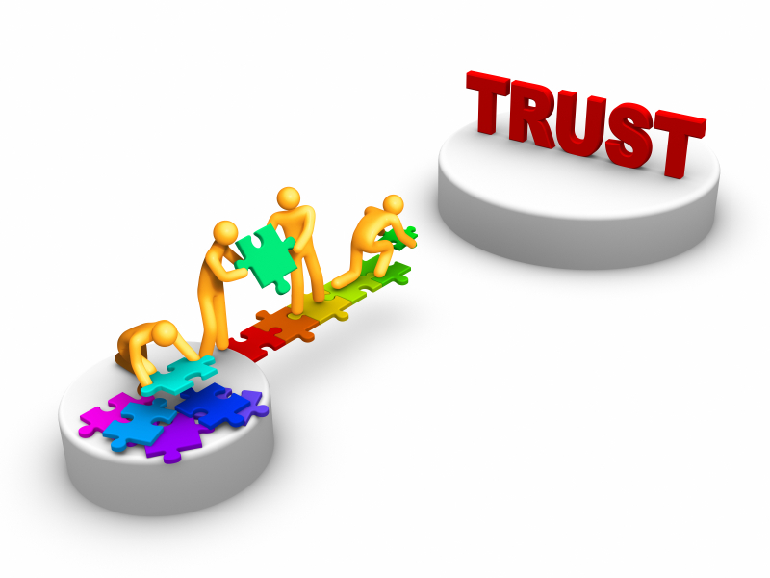

Have the trust and confidence of:

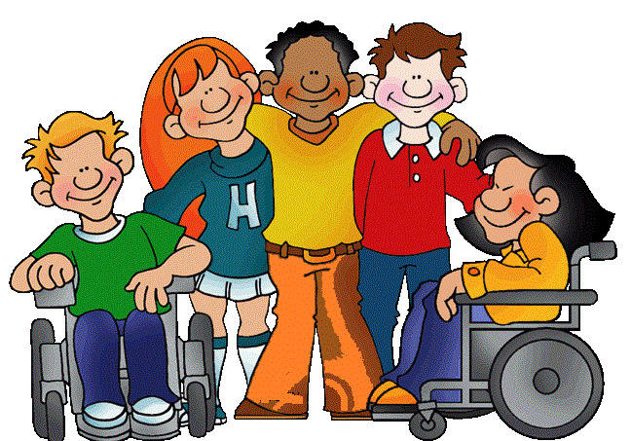

The Deaf and disability communities



The Government, but still being independent

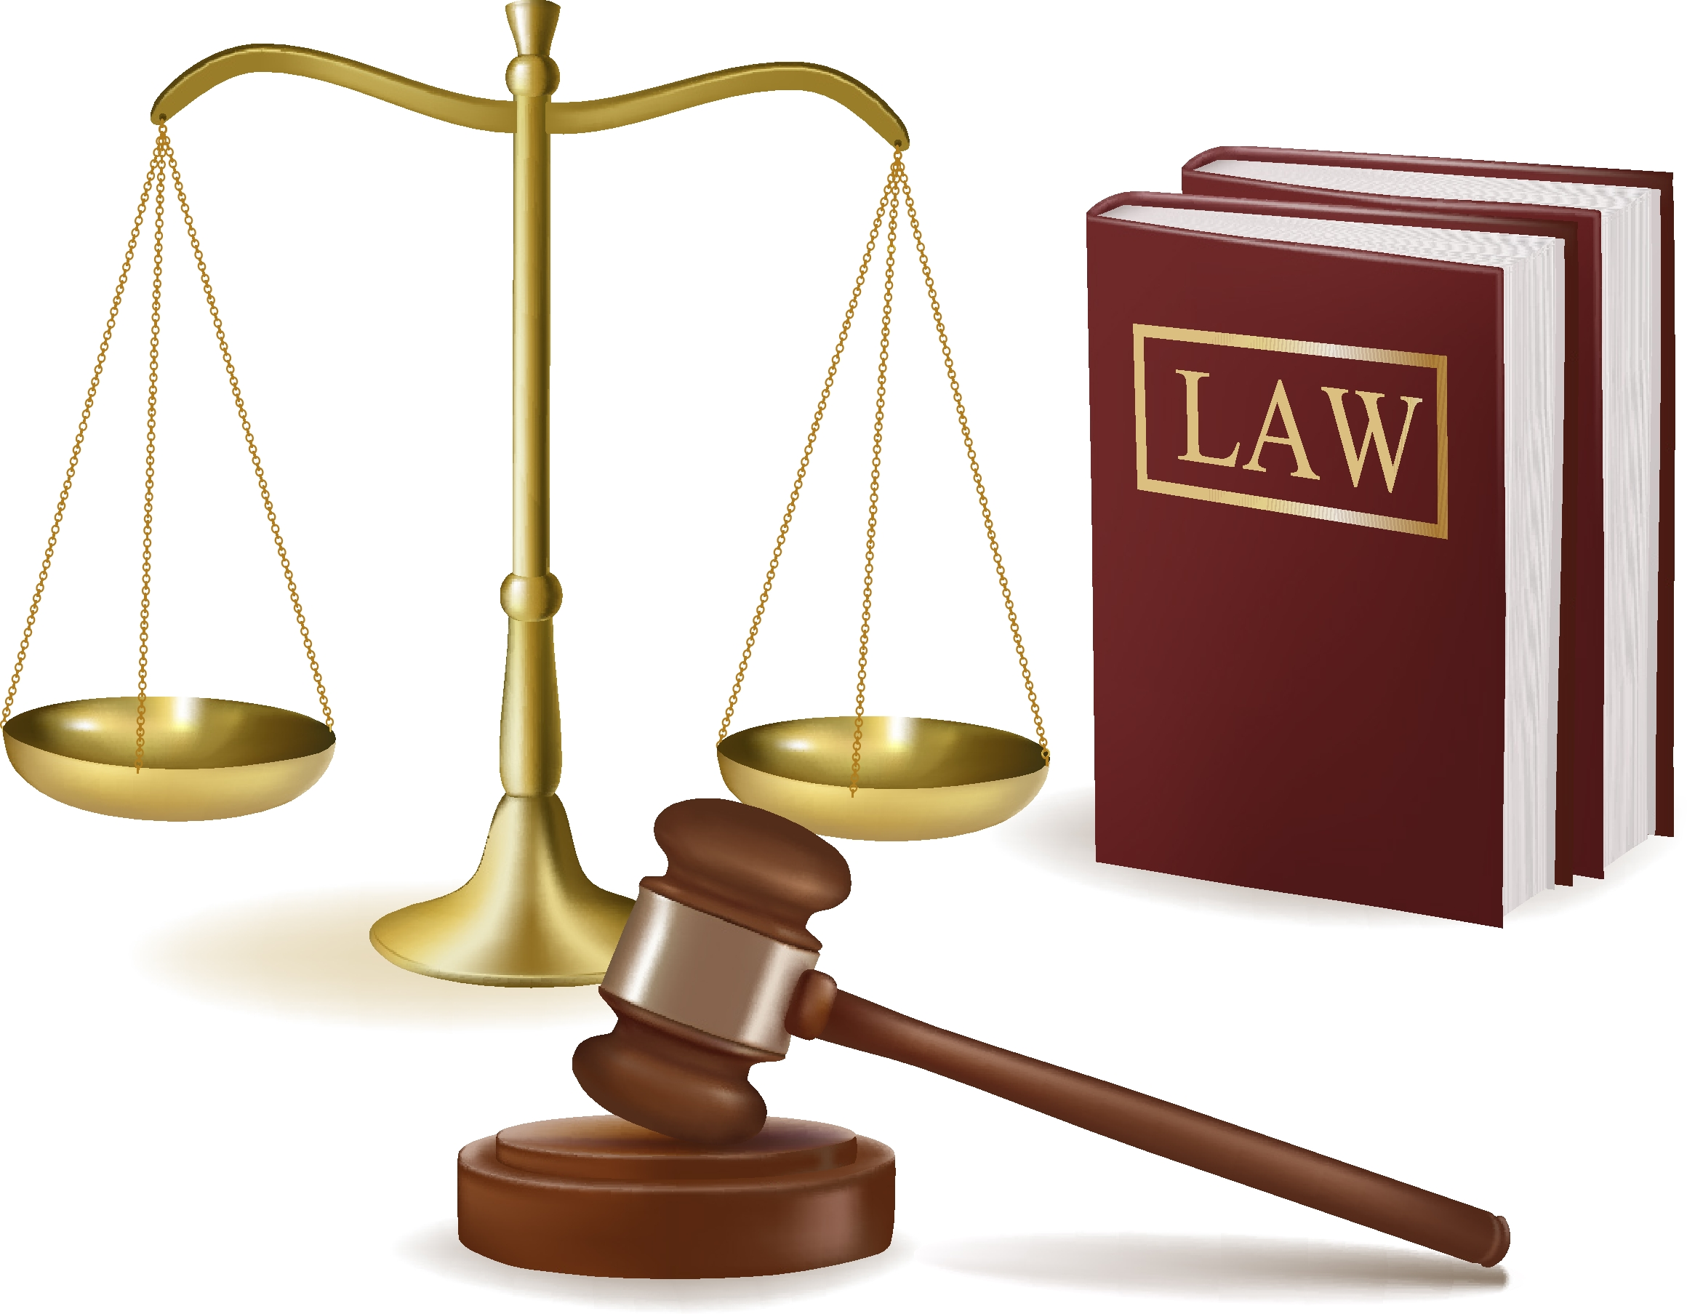

The Justice System



OUR KEY STRATEGIES

A) Make sure our three main activities are able to take place:


Law reform – through our legal knowledge we can represent our communities to make justice happen –– helps us change the law to reduce need



Education - Our legal education work increases our communities understanding of law and their rights and helps them to solve their issues.

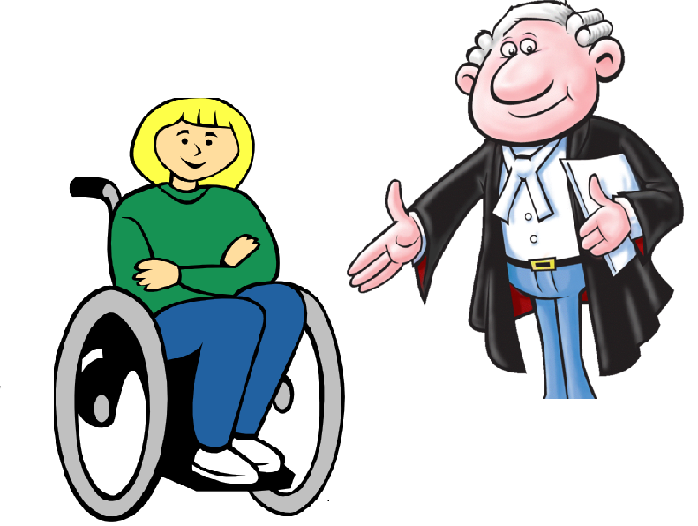

Legal Services – we will improve people’s lives, making sure disabled people have direct access to disability lawyers and get justice


B) Provide quality Frontline services:

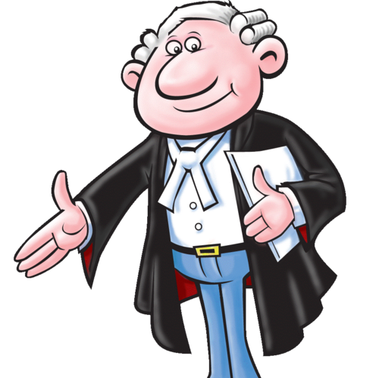

We will improve lives through excellent legal casework services

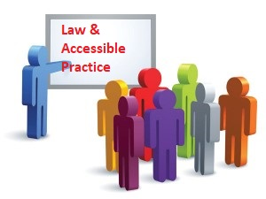

We will improve legal access by teaching professionals about the law and accessible legal practice

We will stop problems from happening at the start, by providing high quality information and education to the Deaf and disability communities and other relevant groups.

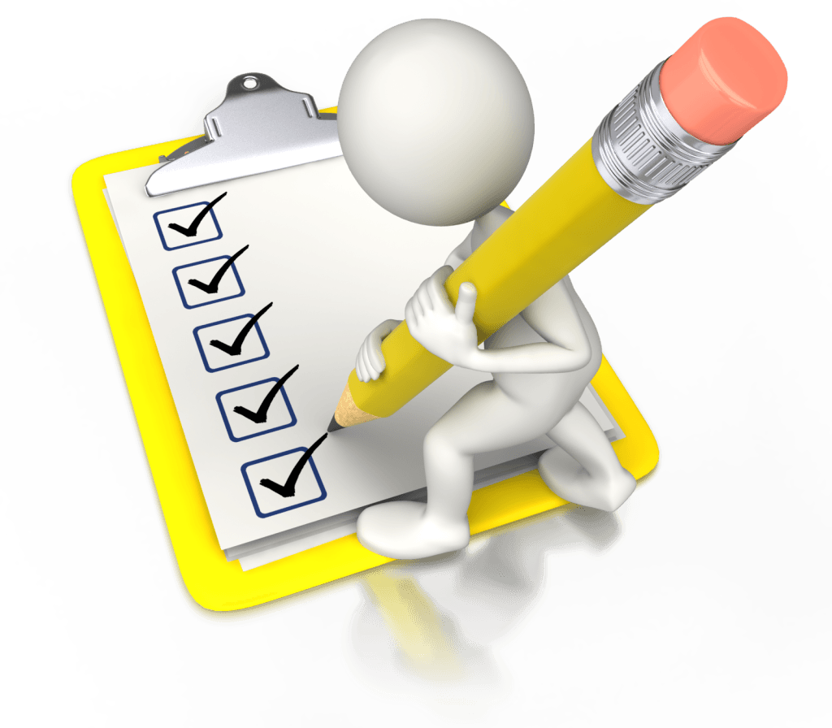

Through the cases we see we will identify the major problems in services and policies and try to fix them.


C) Work fixing systems – also known as ‘systemic impact work’:



We will work to change the legal system to make it fairer and accessible

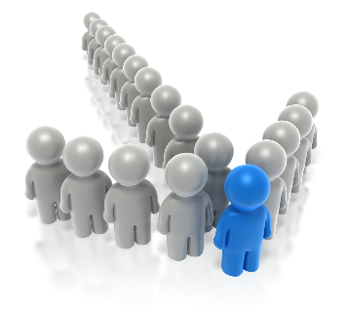

As we are both a legal organisation and a disability organisation, we will use our position in these sectors and knowledge of these sectors to make positive change

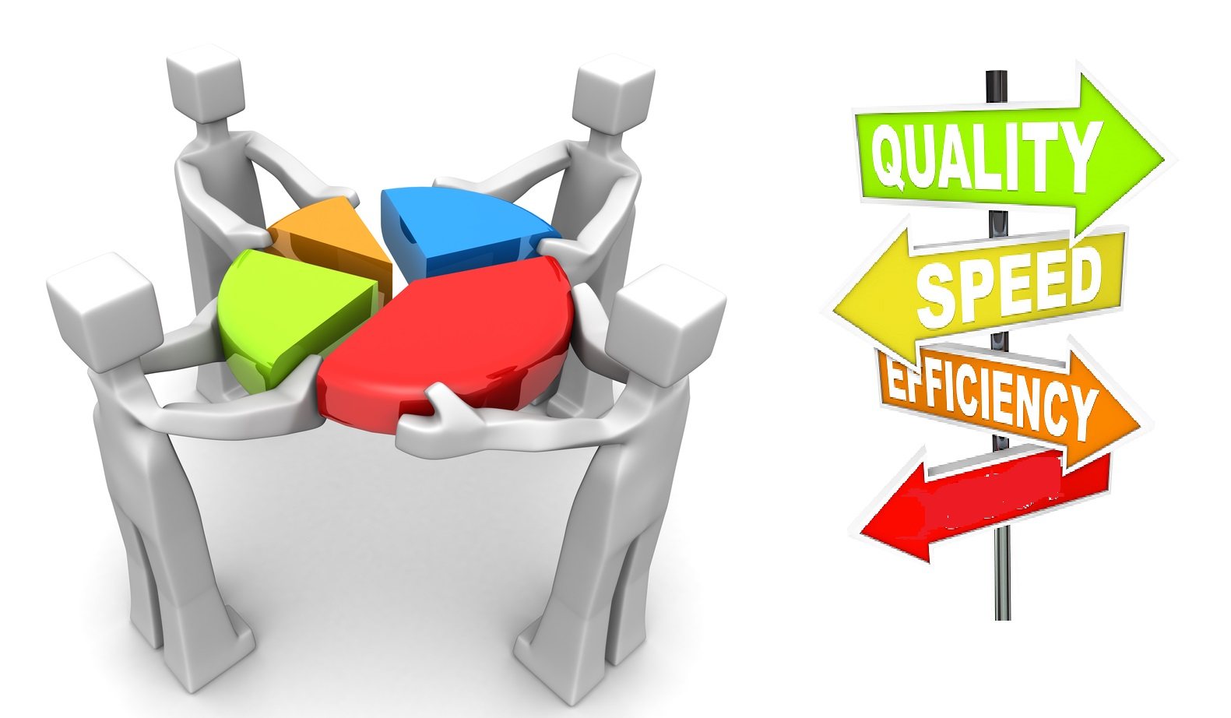

We will combine our legal services with this work fixing systems (systemic impact work).


D) Make decisions based on evidence:



We will use evidence from what we have seen and what we have experienced to make the right choices

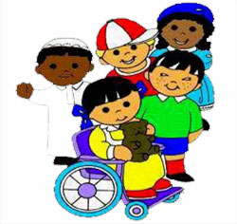

We will choose activities that have a strong effect and influence

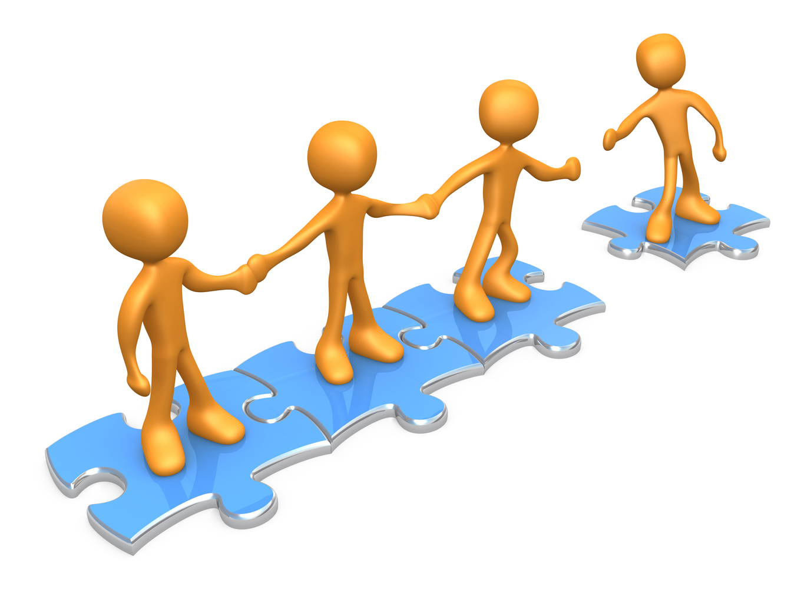

We will take great care to work carefully and cover every detail when preparing for new activities

E. Build great relationships:

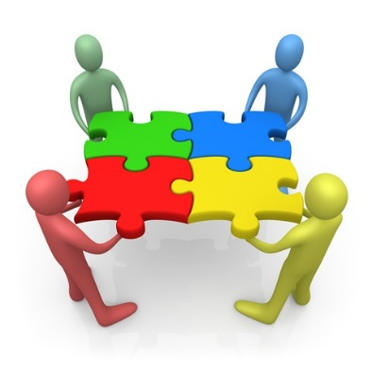

We will be guided by the principle that we cannot reach our goals alone

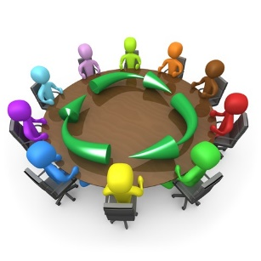
We will work together with services who can do some of the work for us (and who’s work we also support), including:

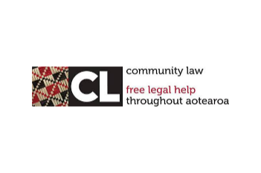

With Community Law Centres


With government, academic and policy influences

With Deaf and disability organisations




With Maori, Pasifika and all nationalities

HOW WE DO IT

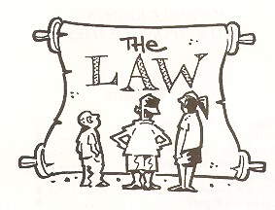

Law reform activities:

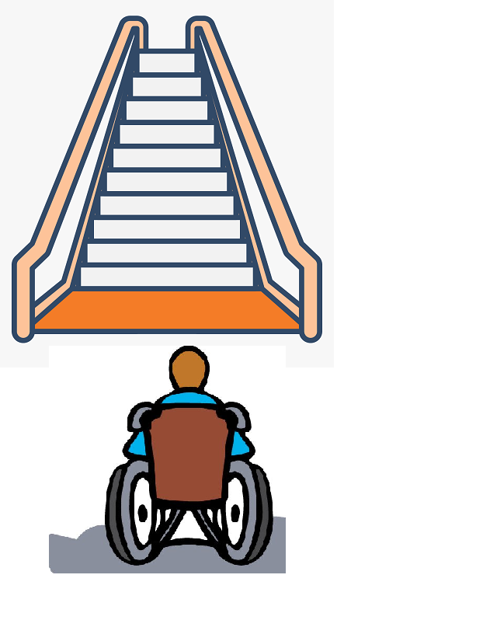

Targeted at issues we discover in our casework

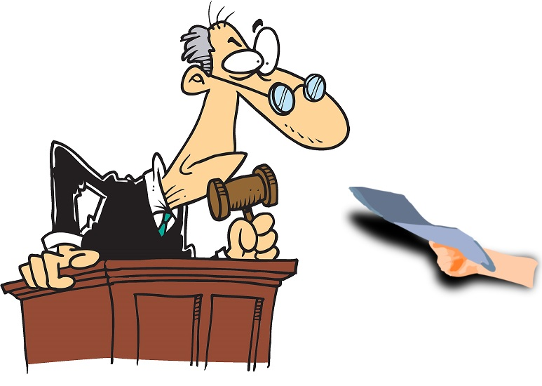

using a range of tactics, including written documents setting out our view, called submissions

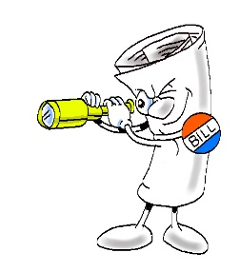
Bring issues highlighted from court cases and other places to people’s attention

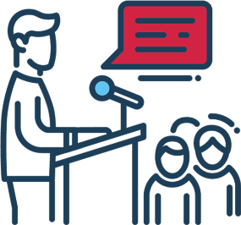
Using the media, planned campaigns of action and other available methods.

Legal education services

That build skills and ability to do disability legal work for the legal profession. Teaching lawyers what is accessible legal practice, and how to identify and fix disability related legal issues

That build skills and knowledge within the Deaf and disability community, including with their supporters.

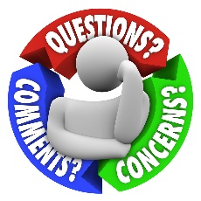
Legal services



Delivered to the right people, letting them know we are the first stop for their legal support, all through New Zealand

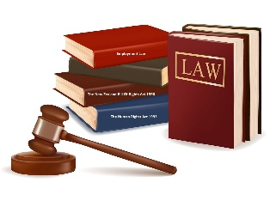

With a range of areas of knowledge and skill

Working with other services so a variety of needs can be addressed
Delivered in a complete, accessible, wraparound way, dealing with the whole situation.


Supported by a large network of skilled staff and trained ‘pro bono’ lawyers meaning they work without charge, as well as volunteers.
Which includes where suitable a service that takes disputes to court, known as a litigation service.

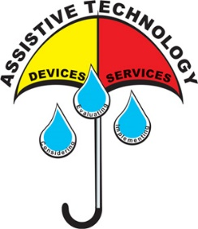

Resources


A team with a variety of skills necessary to deliver our current and future services.



Large network of trained volunteers and lawyers, who work without charge – pro bono lawyers.

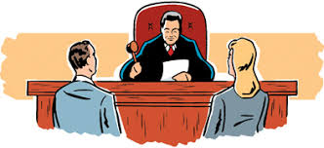
Full range of accessible information on accessible legal practice, common legal issues faced by Deaf and disability community, and disability related legal issues


Access to a wide range of previous legal decisions on the law, which are known as precedents

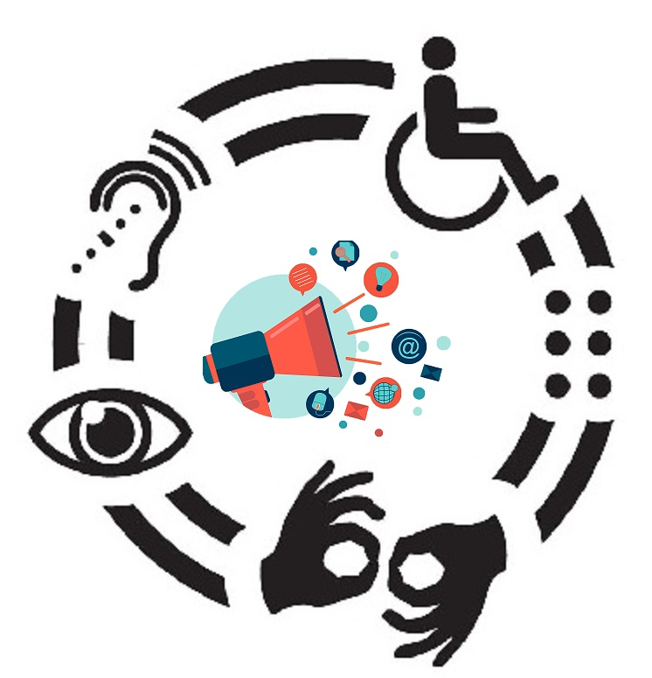
Accessible digital channels such as computers and non-digital channels, such as telephone for undertaking our work.


Great Reputation



Keep a high profile by leading from the front when dealing with disability law matters.

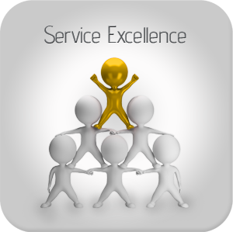

Known for excellence

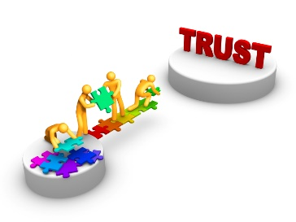

Trusted by the Deaf and disability community

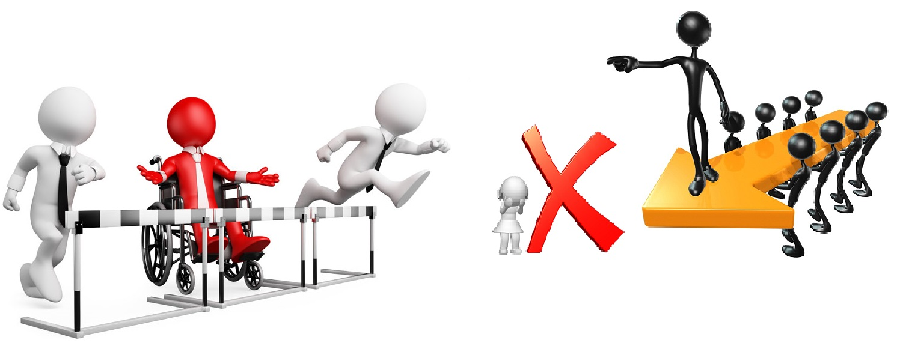

Be regularly asked by government and stakeholders for our views

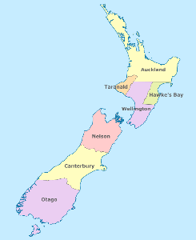

National Service

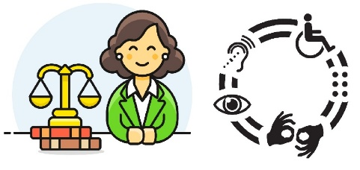

Staff operating from several local Community Law Centres in both North and South Islands

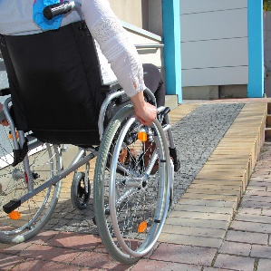
Accessible office

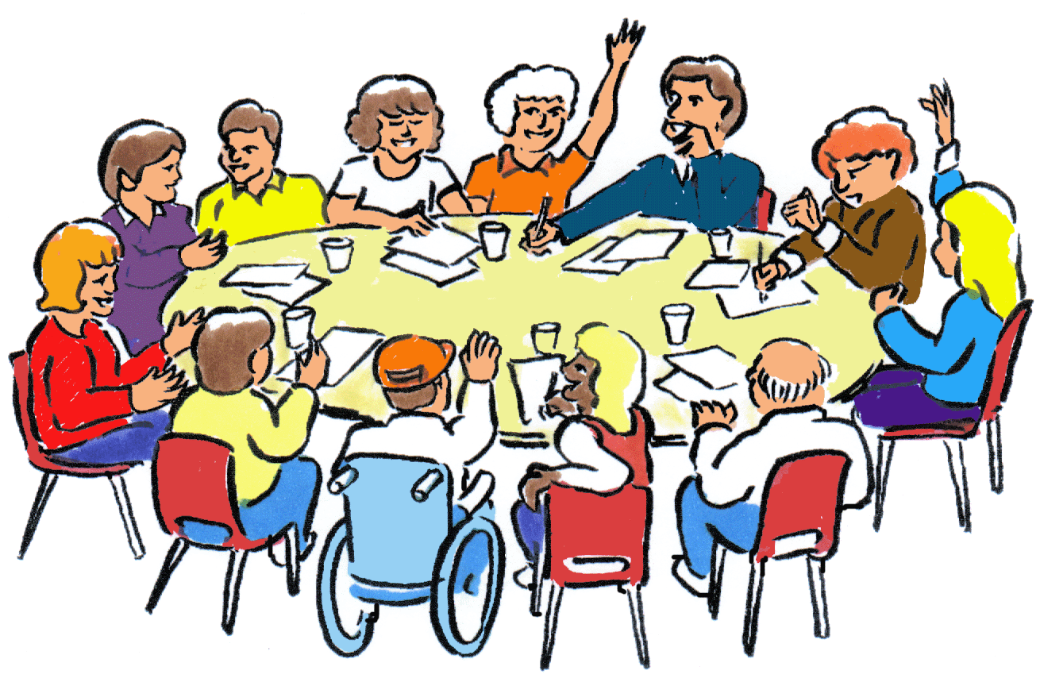
Have a national board responsible for governing and strategic direction.

Systems and technology, including:



Professionally built, accessible website



A website that allows ADL to work with its clients easily including the ability to do email promotions through it.

